Alexander Baldree
07/17/26
Module 8.2 Project Part 3
CSD430

GitHub Link:
https://github.com/Panda-Alex21687/CSD430

Compiled Java Files:
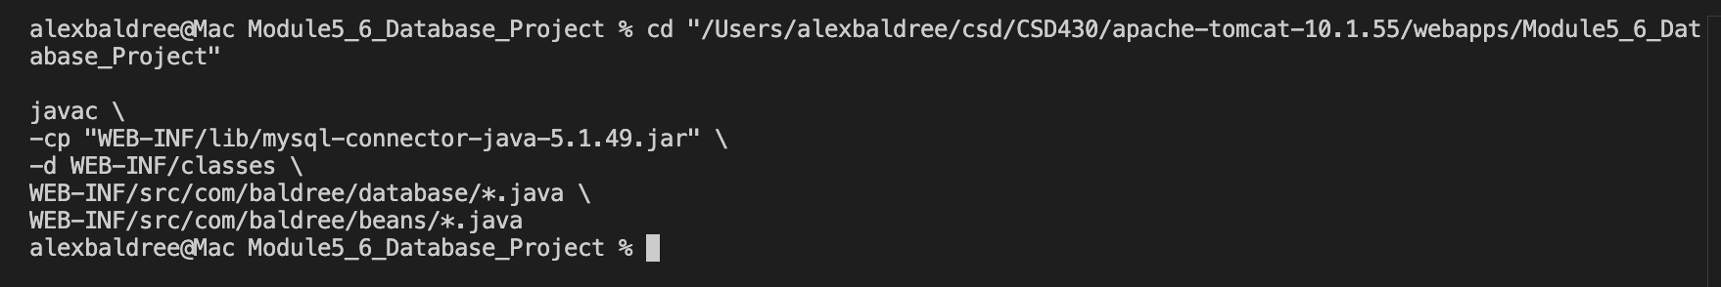
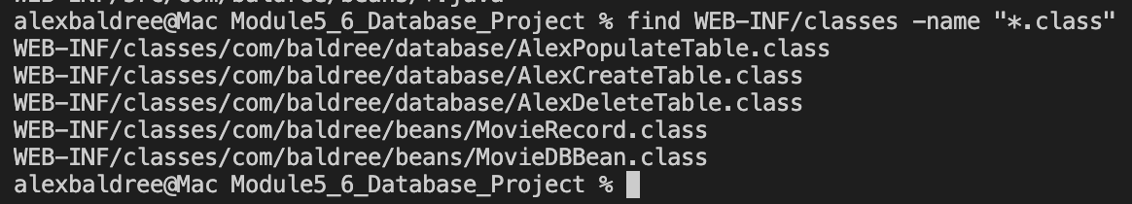

Database Records:
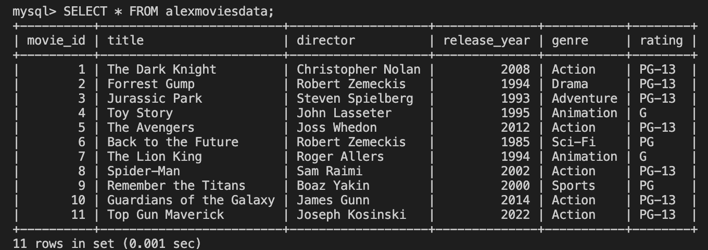
Started Tomcat:
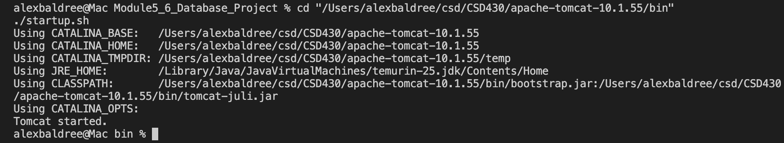

Module 8 Start Page:
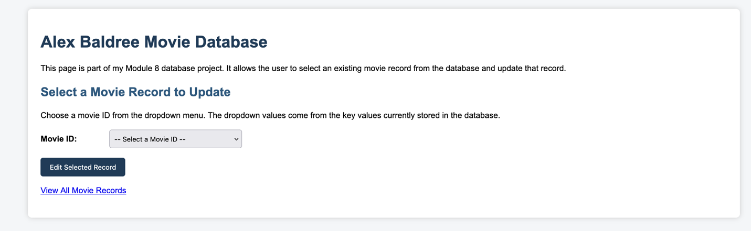
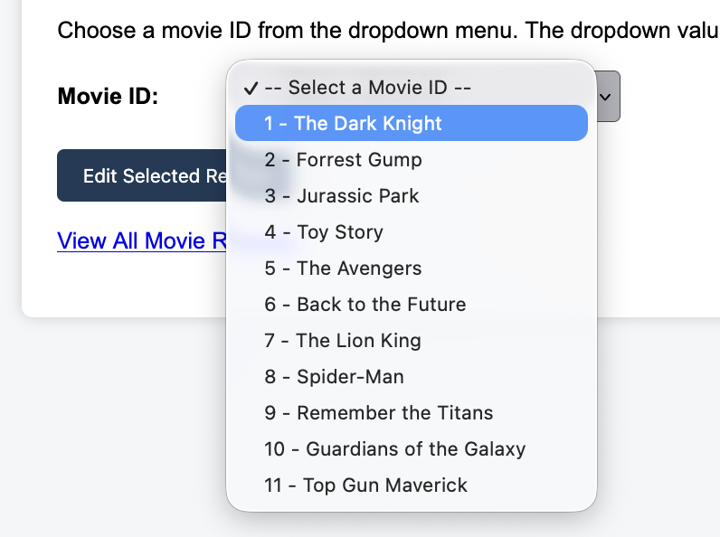

Edit Movie Record:
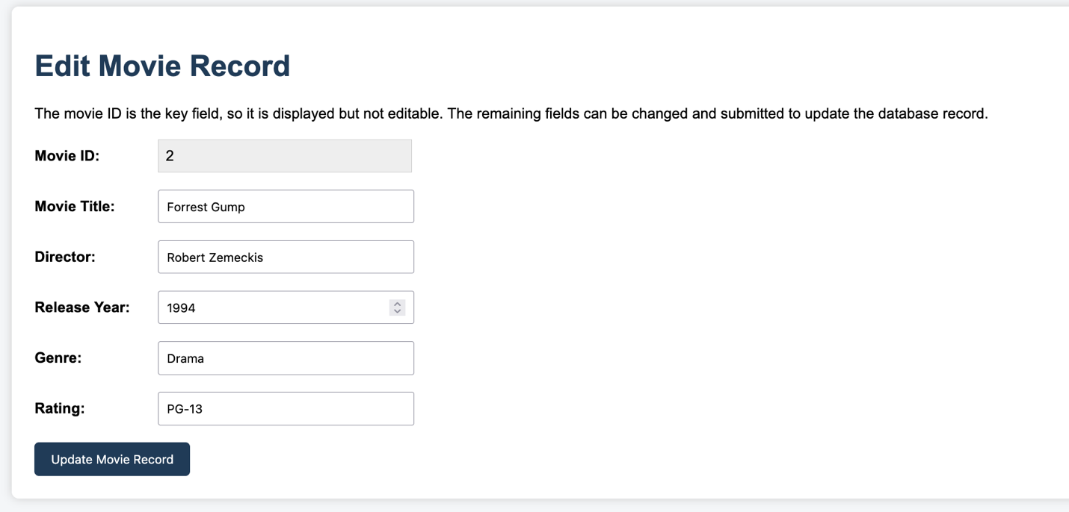

Movie Record Updated:
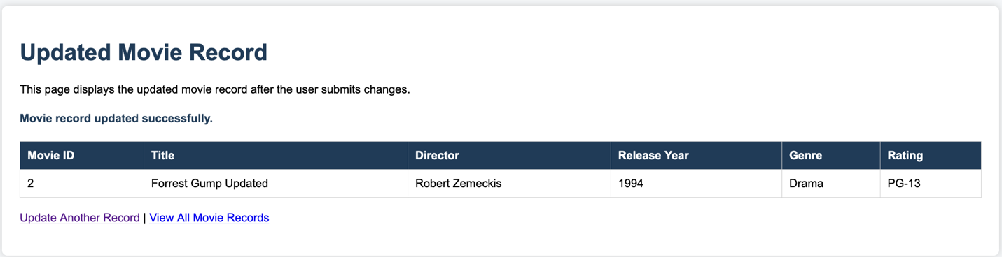

Displays All Movie Records:
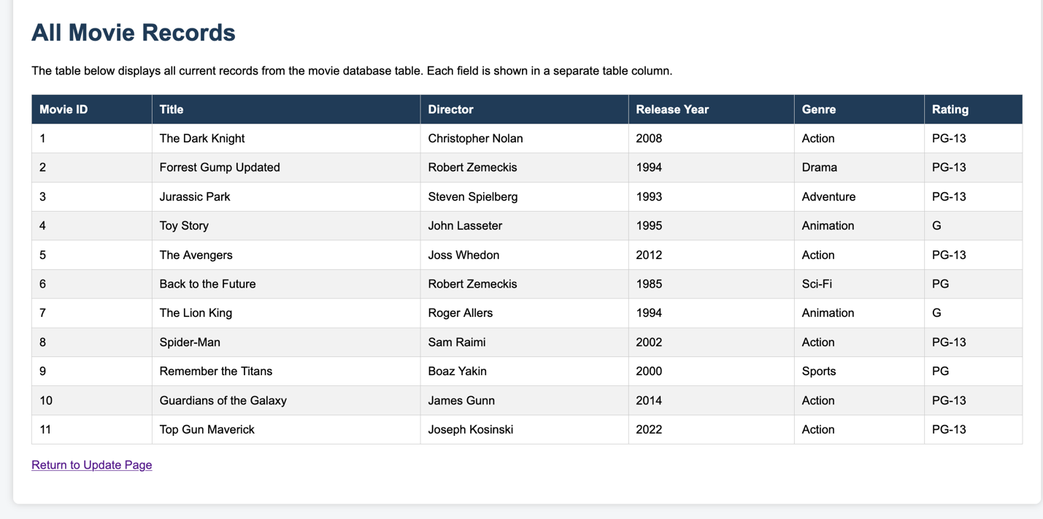

MySQL Updated:
